**Atlantis – SERVER MIGRATION – LIVE**

**Version 2012.1.3**

# Important information- Implementation Code:

Imp Code: **ATL** (always use Capital letters)

# Pre-Requisites for Migration:

Please check if you have installed the following prerequisite in your DB server:



1. Confirm that there is at least 5 GB of free space on the server hard drive (C: drive in addition to database space on D: or other location).

2. Install and configure SQL Server 2012. (For service packs or cumulative updates, please check with ACTIVE Network.) Refer to Installing SQL Server 2012 and Configuring SQL Server 2012 (above document).

3. Install Microsoft .NET 4.5, if not RTP|ONE Database Installer will prompt to download.

5. Configure Windows Firewall for RTP|ONE. Refer to Configuring Windows Firewall (refer above document)

6. Install Internet Information Services (IIS). Refer to Installing IIS ( refer above document)

7. Check if following is enabled:

• Ad Hoc Remote Queries

--Check if Ad Hoc Remote Queries is enabled

SELECT CONVERT(INT, ISNULL(value, value_in_use)) AS config_value

FROM sys.configurations

WHERE name = N'Ad Hoc Distributed Queries' ;

-- Run below to enable it

EXEC sp_configure 'show advanced options', 1

RECONFIGURE

GO

EXEC sp_configure 'ad hoc distributed queries', 1

RECONFIGURE

GO

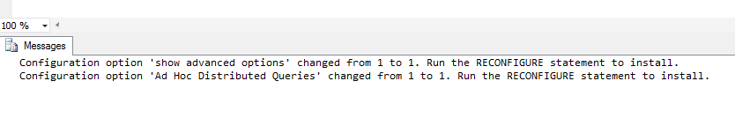

• CLR integration

--Check if CLR is enabled

SELECT * FROM sys.configurations

WHERE name = 'clr enabled'

-- Run below to enable it

sp_configure 'show advanced options', 1;

GO

RECONFIGURE;

GO

sp_configure 'clr enabled', 1;

GO

RECONFIGURE;

GO

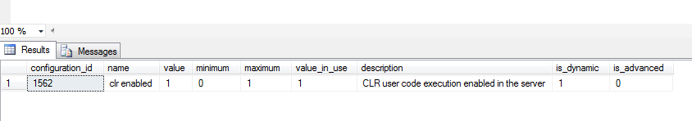

• OLE Automation

SELECT CONVERT(INT, ISNULL(value, value_in_use)) AS config_value

FROM sys.configurations

WHERE name = N'Ole Automation Procedures' ;

sp_configure 'show advanced options', 1

GO

RECONFIGURE;

GO

sp_configure 'Ole Automation Procedures', 1

GO

RECONFIGURE;

GO

sp_configure 'show advanced options', 1

GO

RECONFIGURE;

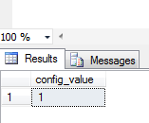

• xp_cmdshell

SELECT CONVERT(INT, ISNULL(value, value_in_use)) AS config_value

FROM sys.configurations

WHERE name = N'xp_cmdshell' ;

-- To allow advanced options to be changed.

EXEC sp_configure 'show advanced options', 1

GO

-- To update the currently configured value for advanced options.

RECONFIGURE

GO

-- To enable the feature.

EXEC sp_configure 'xp_cmdshell', 1

GO

-- To update the currently configured value for this feature.

RECONFIGURE

GO

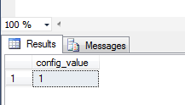

**Once the above is done, we can start with the RTP|One blank DB installation.**

# STEPS FOR MIGRATION

## BLANK DB INSTALLATION:

1. Run 2012.2 RTPOneServerSetup.exe selecting only Database and Reports and install TEST instance
2. Run 2012.2 RTPOneServerSetup.exe selecting only install Database and Reports and install PRODUCTION instance

The following steps need to be done during off hours:

## RESTORE DB

1. Restore a snapshot of the OS
2. Take back-up of RTPOne database from existing server.
3. Restore a .bak of the current production database over newly created RTPOne database.
4. Fix ‘rtpuser’ security (delete ‘rtpuser’ from Databases/RTPOne/Security/Users folder and then update ‘rtpuser’ in main Security folder –User Mapping tab in SQL Server Management Studio). This will dborecreate the rtpuser in RTPOne folder

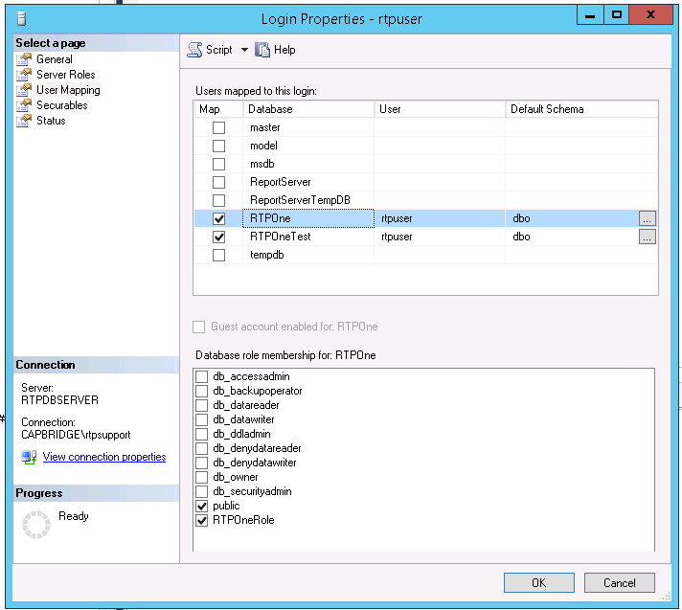

## FIXING REPORTING SERVICES

1. Report Services Homepage – Create ‘Images’ directory on home page and add their logo image
2. Create a ‘reportuser’ in the reporting services

* Go to Server Manager -> Tools -> Computer Management -> Local Users and groups -> Users
* Right click -> New user -> add the user called report user and password: ReportPassword#1
* 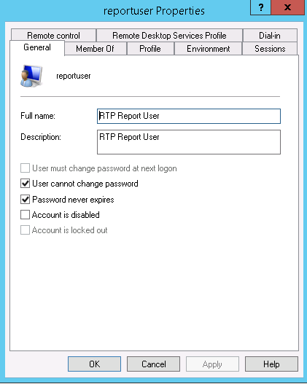
* Save and change these credentials in the report database profile.
* Make sure the client configuration settings are right for report server.
  + Reporting Services Homepage – select Folder Settings and add user, ‘reportuser’ with all privileges

1. Update Server names on restored db within RTPOne:
   1. Client Config Setting 4070: Post Services URL (update to new server name using Bulk Update)
   2. Client Config Setting 1290: Report Server URL (update to new server name using Bulk Update)
   3. Implementation Configuration Setting 11015: (update to new server name)
   4. Report Database Profile: update to new server names (Report Server Name and Test Server Name)
      1. Update Report Server Name and Test Server Name
      2. Update Reporting Services Username = reportuser
      3. Update Reporting Services Password = ReportPassword#1

Here are the below queries:

select * from ClientConfigurationSetting where ConfigurationSettingCode = '4070'

--http://SQLSERVER2008/RTPOneService/Framework/Post.asmx

Update ClientConfigurationSetting set ConfigurationValue = 'http://RTPDBSERVER/RTPOneService/Framework/Post.asmx'

where ConfigurationSettingCode = '4070'

select * from ClientConfigurationSetting where ConfigurationSettingCode = '1290'

--http://SQLSERVER2008/reportserver

Update ClientConfigurationSetting set ConfigurationValue = 'http://RTPDBSERVER/reportserver'

where ConfigurationSettingCode = '1290'

select * from ImplementationConfigurationSetting where ConfigurationSettingCode = '11015'

--http://SQLSERVER2008/RTPOneService/Documentation

Update ImplementationConfigurationSetting

set ConfigurationValue = 'http://RTPDBSERVER/RTPOneService/Documentation'

where ConfigurationSettingCode = '11015'

select * from ReportDatabaseProfile

Update ReportDatabaseProfile

set ReportServerName = 'RTPDBSERVER',

TestServerName = 'RTPDBSERVER'

Change Web Access control URL too if doing only migration.

1. Create RTPDBSERVER\reportuser in Security Logins

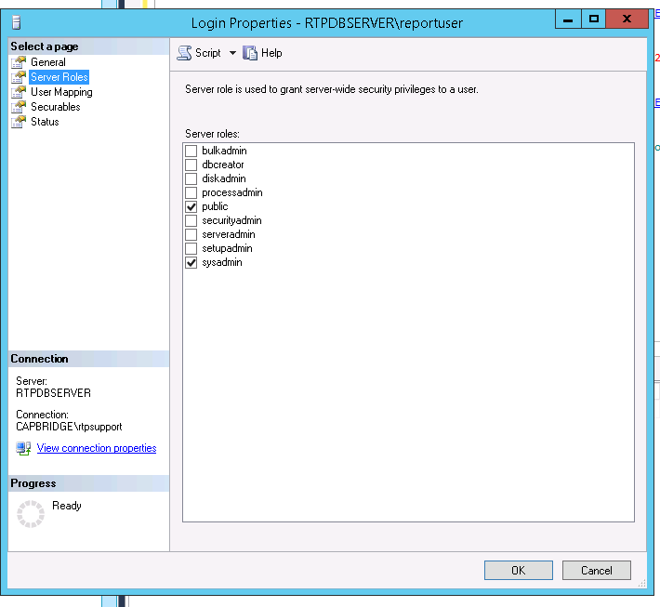

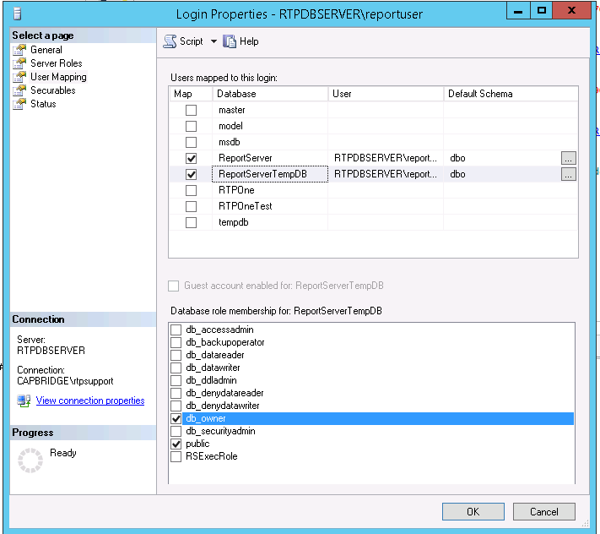

And then go to reporting services and add the users in two places i.e Site settings and Home Page -> Folder settings

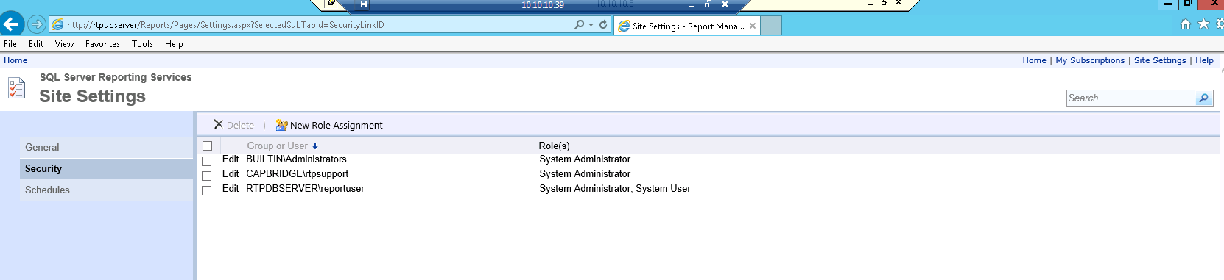

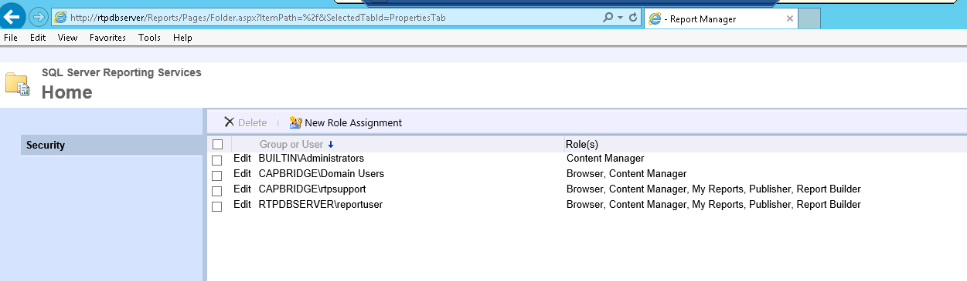

1. Configure SQL jobs (i.e. the time and other stuffs). Enable RTPOne – Auto Client Close job

# UPGRADE:

## 2013.1.1.1 Installation

**DB/ Report Server (always do first):**

* Login to their DB and Report Server
* Check if the Job ‘Create RTPOneTest from RTPOne database’ was run today. If not kick off the Job (not needed if we are doing test and live upgrade together)
* Check the DB version.

select * from Dbversion (nolock)

order by updatedate desc

* Right Click the Database Engine and click Activity Monitor to check no one has logged on to the RTPOneTest Database. If they have, notify them to log off.

### Test – DB Server - 2013.1.1.1 Installation

1. Go to the DB server
2. Run the Server setup installer in the DB and Reports server, selecting only the DB and Reports here.

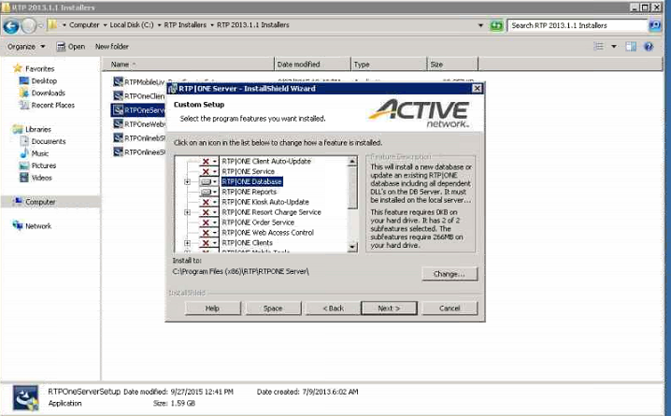

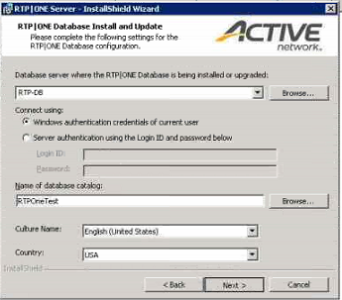

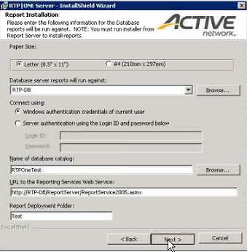

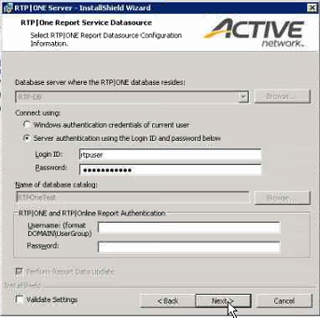

Then Click Install.

### Test – App Server - 2013.1.1.1

1. Go to the App Server
2. Run the Server Setup installer as admin and Select, Client Auto-Update, Service, Kiosk Auto-Update, Web Access Control, Web Components

### Live – DB Server 2013.1.1.1 Installation:

1. Go to the DB server
2. Run the Server setup installer in the DB and Reports server, selecting only the DB and Reports here.









Then Click Install.

### Live – App Server - 2013.1.1.1

1. Go to the App Server
2. Run the Server Setup installer as admin and Select : Client Auto-Update, Service, Kiosk Auto-Update, Order Service, Resort Service, Web Access Control, Clients, Mobile Tools, Web Components

## 2015.2.0 Installation:

### **Pre-Requisites for Upgrade:**

**(RTPOne Server Setup Application User’s Guide - See Section 4.1 – Prerequisites for the RTP|One Database Installer)**

1) Windows Management Framework 3.0 - for server 2008/2008 R2

--You do not need to install Windows Management Framework 3.0 if you are using Windows Server 2012 or 2012 R2

2) Data-Tier Application work 11.1.2902.0 or higher

3) Update the snapshot properties for your RTP|ONE databases as follows:

* From SQL Management Studio, locate your RTPOne or RTPOneTest database and ensure that it is not being used currently.
* Right-click and select Properties.
* On the Database Properties form, select the Options page.
* In the Miscellaneous section, set both of these options to True: − Allow Snapshot Isolation − Is Read Committed Snapshot On
* Click OK. Click Yes when prompted to confirm your changes. All open connections to the RTPOne database will be forcibly closed.

4) Take a backup of the DB server just before you start upgrade and make sure no one has logged in.

Also, please make sure to put each installer in the appropriate server before the upgrade session.

### Test - DB Installation:

Right click> Run as Administrator

* RTP|One Database Server:
* Database: RTPOneTest
* Version: Leave as default
* IMP Code: ATL
* Use SQL Authentication: not checked
* Check all boxes in Show Advanced Options except ‘Deployment Report Only’.

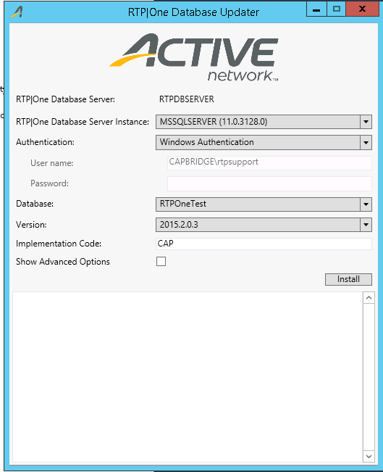

### Live - DB Installer:

* Right click> Run as Administrator
* DB Server: Enter DB Server Name- RTPDBSERVER
* Connect Using: Windows Auth
* Database Catalog (database name): RTPOne

### Test - Report Installer:

Before running the installer, run the <https://localhost/reports> to check if the Reporting Services is working fine.

* Right click> Run as Administrator
* RTP|One Database Server Name: RTPDBSERVER
* Database: RTPOneTest
* IMP Code: ATL
* Use SSL: not checked
* Reports Root Folder: /Test
* Use SQL Authentication: not checked
* RTP|One Data Source Username: rtpuser
* RTP|One Data Source Password: rtppassword
* Make sure you do not check the Ignore Report Upload errors and Test check box in the Advances Options.

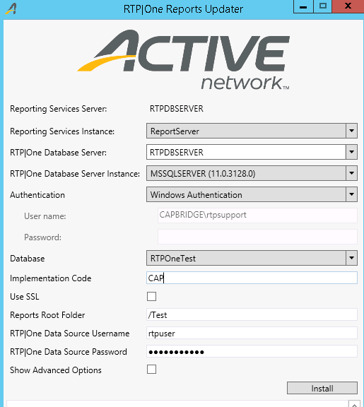

### Live – Report Installation

Before running the installer, run the https://localhost/reports to check if the Reporting Services is working fine.

**Form Properties:**

* Report Installation Form
  + Letter
  + DB Server: Enter DB Server: RTPDBSERVER
  + Connect Using: Windows Auth
  + DB Catalog (name): RTPOne
  + URL- leave as default: <http://RTP/ReportServer/ReportService2005.asmx>
  + Folder: Leave blank
  + Culture Name: Leave as default: English (United States)
  + Report Service Datasource
  + DB Server: will default to one selected on previous form (RTPDBSERVER)
  + Connect Using: Server Auth- rtpuser/rtppassword
  + DB Catalog (name): Will default to selection on last form (RTPOne)
  + RTP|ONE and RTP|Online Report Authentication: leave this blank
  + Check- Perform Report Data Update
  + Check- Validate Settings
* 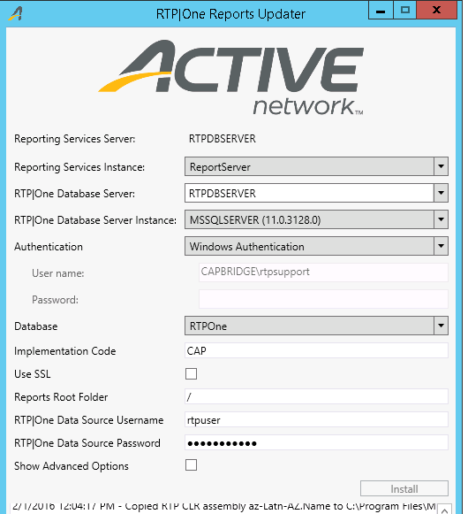

### Test and Live Postal Code Update:

* **Run 2015.2.0 ‘RTPOneDbUpdater’– Upgrade RTPOneTest**
* **Run 2015.2.0 ‘RTPOneDbUpdater’– Upgrade RTPOne**

### Test – Server Setup Installation

**Go to the APP server**

* Right click> Run as Administrator

**Select:**

* RTP|ONE Client Auto-Update
* RTP|ONE Service
* RTP|ONE Kiosk Auto-Update
* RTP|ONE Web Access Control
* RTP|ONE Clients
* RTP|ONE Mobile Tools
* RTP|ONE Administration Data Update
* RTP|ONE Settlement Service (this only installs the settlement service installer)

Never select during test update:

* RTP|ONE Resort Charge Service
* RTP|ONE Order Service
* RTP|ONE LMS Reprocess Service
* RTP|ONE MWare
* RTP|ONE Inventory Distribution
* RTP Distribution Agent Service

**Form Properties:**

* RTP|ONE Client Auto-Update/ RTP|ONE Kiosk Auto-Update
  + Leave as the defaults:
* RTP|ONE Client Application
  + DB Server: Enter DB server name: RTPDBSERVER
  + Connect Using: rtpuser/rtppassword
  + Name of Database Catelog: RTPOneTest
  + Login ID: leave blank
  + URLS: Leave as defaults
  + Use Windows Auth: false
  + Show Logon Soft Keyborad- You decide
  + Allow Multiple Instances: No
  + Local Offline Operation: False
  + Check- Validate settings
* RTP|ONE Administration Data Update
  + DB Server: Enter DB server name: RTPDBSERVER
  + Connect Using: Windows Auth
  + DB Catalog: RTPOneTest
  + Check- Perform Admin Data Update
* RTP|ONE Service Installation
  + DB Server: Enter DB server name: RTPDBSERVER
  + Connect using: server auth: rtpuser/rtppassword
  + DB Catalog: RTPOneTest
  + URL: Leave as default
  + Check- Validate Settings

### Live – Server Setup Installation

Note the client code and login ID in the ResortCharge.config and RTPOrderService.config

**Select:**

Run as Administrator-> Click Install as new instance

* RTP|ONE Client Auto-Update
* RTP|ONE Service
* RTP|ONE Kiosk Auto-Update (if you use kiosks)
* RTP|ONE Resort Charge Service
* RTP|ONE Order Service
* RTP|ONE Web Access Control
* RTP|ONE Clients
* RTP|ONE Mobile tools
* RTP|ONE Settlement Service (this only installs the settlement service installer)
* RTP|ONE Web Components

Never select during live update (simply check all except the following):

* RTP|ONE LMS Reprocess Service
* RTP|ONE MWare
* RTP|ONE Inventory Distribution Service

Note: NEVER select RTP|ONE Resort Charge Service and RTP|ONE Order Service while TEST upgrade.

**Form Properties:**

* RTP|ONE Client Auto-Update/ RTP|ONE Kiosk Auto-Update
  + Leave as the defaults:
    - [http://<<DB SERVER NAME>>/AutoUpdate/Version](http://SRV-CPR-RTPDB1/AutoUpdate/Version)
    - [http://<<DB SERVER NAME>>/KioskAutoUpdate/Version](http://SRV-CPR-RTPDB1/KioskAutoUpdate/Version) (this will only show if you select to install kiosk)
* RTP|ONE Resort Charge Service (if you aren’t sure about the properties to enter- open the config file for this within the directory)
  + DB Server: <<DB SERVER NAME>>
  + Connect Using: Server Auth- rtpuser/rtppassword
  + Database Catalog (db name): RTPOne
  + Client Code: get from config files or use a valid client code
  + Use Windows Auth: False
  + Login ID: get from config files or use a valid container login id
  + Send Email At Startup: your choice- most likely not
  + Mail fields: enter as needed
  + Recover OCV: False
  + Check-Validate Settings
* RTP|ONE Order Service (if you aren’t sure about the properties to enter- open the config file for this within the directory)
  + DB Server: Enter <<DB SERVER NAME>>
  + Connect Using: Server Auth- rtpuser/rtppassword
  + Database Catalog (db name): RTPOne
  + Client Code: get from config files or use a valid client code
  + Login ID: get from config files or use a valid container login id
  + Process Interval: Leave as default
  + Use Windows Auth: False
  + Email Exceptions: use all these information same as previously setup (get the information from the config file)
  + Check-Validate Settings
* RTP|ONE Client Application
  + DB Server: <<DB SERVER NAME>>
  + Connect Using: rtpuser/rtppassword
  + Login ID: delete out-leave blank
  + URLS: Leave as defaults
  + Use Windows Auth: false
  + Show Logon Soft Keyborad- You decide
  + Allow Multiple Instances: No
  + Local Offline Operation: False
  + Check- Validate settings
* RTP|ONE Administration Data Update
  + DB Server: <<DB SERVER NAME>>
  + Connect Using: Windows Auth
  + DB Catalog: RTPOne
  + Check- Perform Admin Data Update
* RTP|ONE Service Installation
  + DB Server: <<DB SERVER NAME>>
  + Connect using: server auth: rtpuser/rtppassword
  + DB Catalog: RTPOne
  + URL: Leave as default
  + Check- Validate Settings
* Check if the resort Services is running.

### Live - Settlement service:

Go to the RTP One server folder and open the settlement service installer.

Run the installer with necessary setting from the config file(steps as above).

[Example screenshot below]

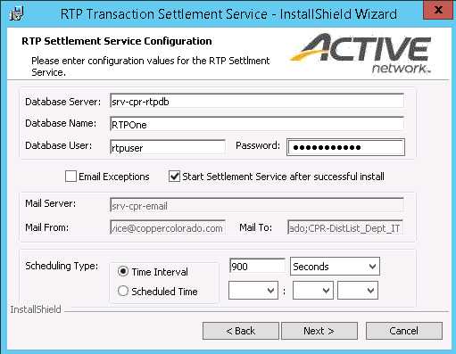

### Web Components – Order Processing - Test and Live

* Go to the RTPOne Server folder -> RTPWebComponents Install
* Check if the updater is recently updated.
* Run the installer
* Go to the Web.config file and change the Client code to100.

### TESTING

* Launch RTPOne from desktop to auto-update (or install 2015.2.0 version from C:\Program Files (x86)\RTP\RTPONE Server\RTPOneClientInstalls\RTPOneClient)

Run the Queries:

* select * from functionset (nolock)

where FunctionSetCode = '10001' -- Note the URL here

update functionset

set url = 'http://RTPDBSERVER/WebAccessControl_Test'

where FunctionSetCode = '10001'

* select * from UserSession

Check the User session table is it has the '1000001' session token. If not enter the following:

INSERT INTO UserSession VALUES ('1000001','1000001','1000',1,'ADMIN','ADMIN', GETDATE(),1)

Test if the RTP one is updated and if it is working fine (test steps attached)



### Estore Test and Live Installation:

* Now log into Estore Server. And copy out the estore_test or estore_prod folder and rename it with the date. If we run into any error and need to delete the RTOOne folder, we need to copy the App_Themes and MyAssets folder to restore the setting and themes
* Open the web config file and note the ThemeName, ClientCode and the InitialAuthenticationUserName used.
* Now go to the estore installer and run as administrator.
* Enter the values noted and leave others unchanged.
* Open the estore test link and check if it is working fine.

### Test - Connect Installation

Prior to Installation in Test, run the installer in your environment and zip up the files extracted and send it to the customer. As we cannot install a test instance for Connect, we need to copy and replace the files. If we install the installer in their environment, it will update the Prod instance.

• Go to the Connect server.

• Open IIS and open the RTPConnect_Test-> Basic Settings. Find the Physical Path.

• Go to ApplicationPools and right click on the ‘RTPConnectTestAppPool’ and click stop.

• Unzip the file given by RTP.

• Copy the RTPConnect_test in the physical path and take a backup.

• Delete the contents of RTPConnect_Test folder in the physical path after backup.

• From the unzip files copy the contents of RTP Connect folder to the RTPConnect_Test folder in the physical path.

• Open the Web.config file

• Change the Initial Catalog as RTPOneTest and DataSource as their DB name in two instances.

• Save the config file.

• Copy the Log4net.config from the backup of their folder and copy and replace all the contents in the log4net.config in the physical path.

• Right click on the AdapterSetting.xml and check the security tab to see if the network service user has all permissions except special permission.

• Check the dll file version of the bin directory to see if the its updates to the version you are trying to upgrade.

• Start the App pool.

• Open the browser: http://<connectservername>/rtpconnect_test/SupplierService.asmx

• Test it by opening the connect client and use the above URL to process a ‘Product Inquiry’ message.

• Ask them the check the others.

### Live - Connect Installation

• Go to the Connect server.

• Open IIS and open the RTPConnect -> Basic Settings. Find the Physical Path.

• Copy the RTPConnect in the physical path and take a backup.

• Run the installer as administrator

• Recycle the App pool.

• Check the dll file version of the bin directory to see if it’s updated to the version you are trying to upgrade.

• Open the browser: http://<connectservername>/rtpconnect/SupplierService.asmx

• Test it by opening the connect client and use the above URL to process a ‘Product Inquiry’ message.

# MONDAY - Steps to be done after restoring snapshot for Atlantis:

* Check if they have more space in C: Drive
* Need to run the DAC installer
* Check if the installers are in place
* Config IIS
* Check if the pre-requisites are complete in all server.